United Nations Population Fund, UNFPA
202-204 Bauddhaloka Mawatha
Colombo 7
Sri Lanka
Tel: +94-11-2580840
E-mail (General): lk-procurement@unfpa.org
Website: srilanka.unfpa.org

Date: 09 November 2022
REQUEST FOR QUOTATION
RFQ Nº UNFPA/LKA/RFQ/2022/013 – ITEMS FOR ELDERLY KITS

Dear Sir/Madam,

UNFPA hereby solicits a quotation for the following items for elderly kits:

Expected Delivery – on or before 12.00 PM, 15 November 2022.
VAT – UNFPA is exempt from VAT. Please submit your quotation excluding VAT. Relevant Government approvals will be shared with selected suppliers.

Minimum Specifications are as follows:
Item | Specification | Photo | Quantity (pcs)
Toothbrush | Toothbrush of adult size, medium hardness, and individually wrapped. Bristles must be free of sharp or jagged edges and endpoints. The bristles must not fall out with normal use. All of the toothbrush components should be safe for use on the human body, made with non-toxic and non-allergic material. Minimum length of handle approximately 150mm made from plastic and shall be free from disagreeable odor; Cleaning element shall consist of nylon filaments, polyester filaments, poly butylene terephthalate filaments, thermoplastic elastomer, polyethylene filaments, polypropylene filaments, or any combinations of above materials and shall be free from any disagreeable odor, taste and toxic elements; The heads of the monofilaments shall be polished to give them round shape. The number of monofilaments should be 300 minimum. The toothbrush must contain a reusable protective cover that will cover all the bristles entirely. | 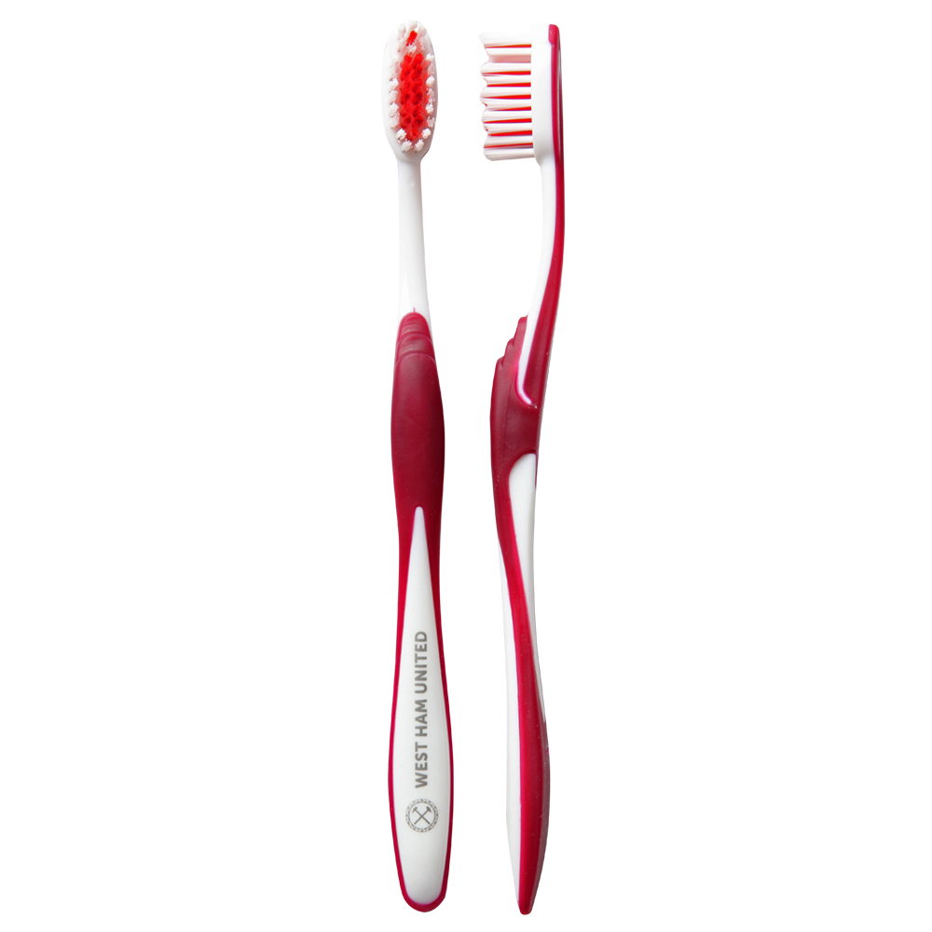 | 1200
Soap, bathing | Suitable for adults, preferably non-scented or mild-scented, firm and smooth in texture, Should generally contain fatty acids, surfactants, preservatives and moisture. Able to form a good lather. May also contain suitable quantities of coloring matter. Bathing bars shall not contain any ingredients in amounts that are harmful to the human body and environment. Bar soap should be individually wrapped. One bar of minimum 70g. TFM (total fatty matter) content: Minimum 70 %. Glycerin approx. 1%  Others: approx. 29%  pH Value (conc. 1% at 40ºC) : 9-11.  Products must not contain fat from pigs. The level of sodium hydroxide shall not be more than 0.3%. | 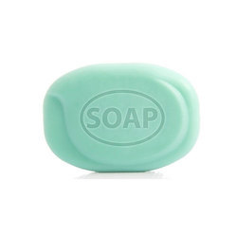 | 1800
Soap, laundry | Suitable for hand washing of laundry, preferably non-scented or mild-scented, firm and smooth in texture, Should generally contain detergents, fatty acids, surfactants, preservatives and moisture. Able to form a good lather. May also contain suitable quantities of coloring matter. Detergent bars shall not contain any ingredients in amounts that are harmful to the human body and environment. Bar soap should be individually wrapped. One bar of minimum 100g.  TFM (total fatty matter) content: Approximately 50 %. Glycerin approx. 1% | 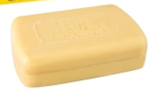 | 1200
Tooth paste, large | Product description: Toothpaste, approximately 70g  Preferably the paste should not contain fluoride (as this product will be distributed to regions with excess levels of fluoride), should be non-flavored or peppermint flavor, with individual wrapping. | 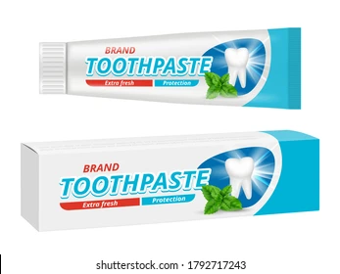 | 600
Shampoo | 90ml Easy-lathering general purpose adult shampoo formulated for all types of hairs, to wash hair and scalp.  Anionic surfactant: Sodium lauryl ether sulfate (SLES 70%), or Ammonium lauryl ether sulfate (ALES) as a possible substitute if SLES not available - 12% Minimum  Non-ionic surfactant (Cocamidopropyl betaine or equivalent) Co-surfactant - 2% Minimum  Sodium chloride (salt) to achieve the required viscosity - Up to 3%  Usually 2.5%  Citric acid or other "organic acids" to obtain required pH - 5<pH<9  Demineralized treated water, bacteriologically clean - By difference to 100 % | 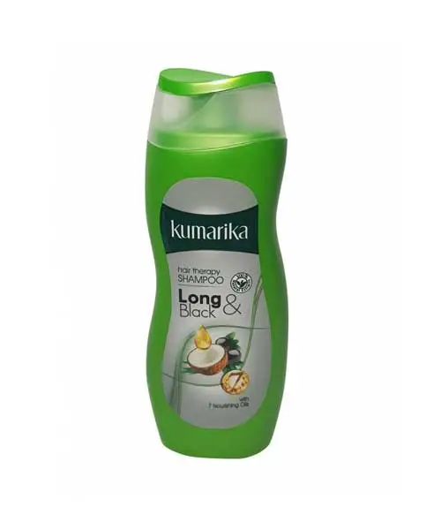 | 1200
Sandal/flip flops | Made up of properly vulcanized natural and synthetic rubber compounds. Cushioned foot bed with rubber sole with y-shaped strap (no sandal or ankle strap).  The IRHD hardness of the rubber outsole should be 60±5 and for the rubber insole it should be 55±5 with the accelerated aging test at 100 deg Cel, it should not reduce by more than 5 units. The sole should have adequate flex and abrasion resistance to serve the period of its use. It should have adequate weathering/ UV resistance as well. Adequate color fastness criteria should be met. Plain foot surface with comfortable and flexible strap.  Rubber compounding should be properly completed to ensure that the allergy causing rubber accelerators should be below the threshold limit to prevent occurring contact dermatitis.  Size: 6”, 7” and 8” | 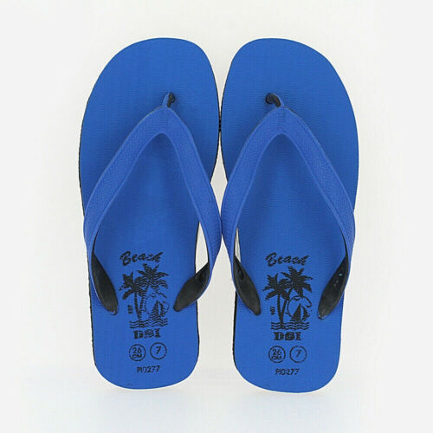 | 600
Pain reliever balm | 15g, with suitable composition of all or either eucalyptus, menthol, camphor, citronella oils, recommended for headaches and minor body aches. | 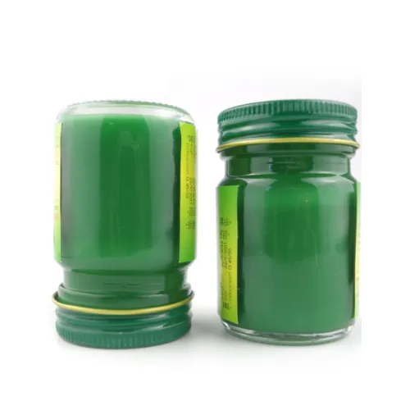 | 600
Cotton buds (1 pack) | Made 100% using pure cotton and Non-toxic material. Pear Shaped, Heat Sealed and Firmly adhered.  Packing: 100 cotton buds in a reusable plastic jar.  Ideally, made of wooden, bamboo, paper or other biodegradable sticks. | 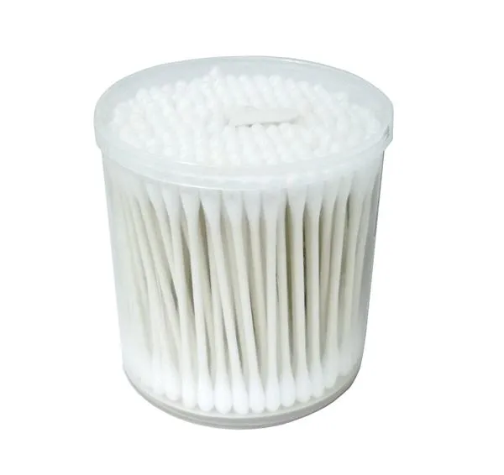 | 600
Water bucket with lid, plastic, large (1 no) | Product Description: Heavy duty bucket with lid, safe for food and water storage. Handle made of plastic of the same material or with galvanized metal. Initially, it will be used to carry dignity kits.  Material specification: made of food grade virgin HDPE (High Density Polyethylene), tough durable  UV-resistant that will not deteriorate in harsh sunlight.  The top is reinforced to prevent ovaling. The walls shall meet the bottom of the bucket with ideally a curved surface to prevent dirt accumulation and facilitate cleaning.  The bucket has a tight fitting lid of the same material of the bucket. The lid can be taken off for periodic cleaning of the bucket. The handle must be sturdy to carry a fully filled bucket weight without bending or shearing off.  Should be able to take weights around 30 kg when used for other purposes.  Size: The bucket capacity of minimum 25 liters. Approximate dimensions are 39 x 28 x 34.5 cm.  Color: Orange. | 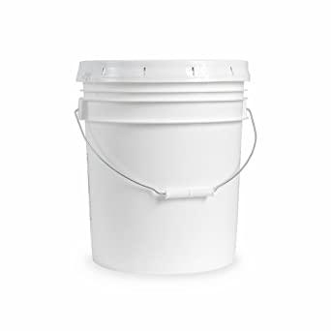 | 600
Plastic Bowl, 3 Liter (1 Pcs) | Product Description: Reusable plastic bowl safe for human body. 3 liter capacity.  Material specification: made of food grade virgin HDPE (High Density Polyethylene), tough durable  UV-resistant that will not deteriorate in harsh sunlight. With a handle made of the same material.  Should hold approximately 3 liters of water.  Size: The capacity is approximately 3 liters.  Color: Orange | 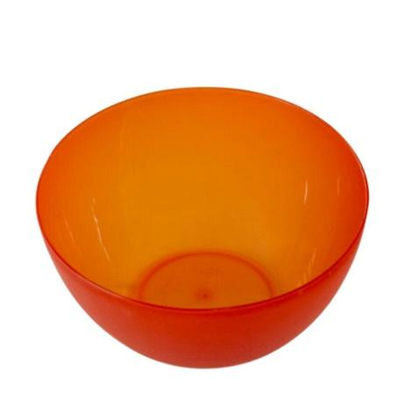 | 600

- About UNFPA

UNFPA, the United Nations Population Fund (UNFPA), is an international development agency that works to deliver a world where every pregnancy is wanted, every childbirth is safe and every young person’s potential is fulfilled.

UNFPA is the lead UN agency that expands the possibilities for women and young people to lead healthy sexual and reproductive lives. To read more about UNFPA, please go to: UNFPA about us

- Questions
Questions or requests for further clarifications should be submitted in writing to the contact person below:

Name of contact person at UNFPA: | Ms. Geetha Fernando
Mobile Nº: | +077 7402022
Email address of contact person: | gfernando@unfpa.org

The deadline for submission of questions is 12 November 2022, 12:00 PM, Colombo time. Questions will be answered in writing and shared with all parties as soon as possible after this deadline.

- Eligible Bidders
This Request for Quotation is open to all eligible bidders; to be considered an eligible bidder for this solicitation process you must comply with the following:

- A bidder must be a legally-constituted company that can provide the requested products and have legal capacity to enter into a contract with UNFPA to deliver in Sri Lanka, or through an authorized representative.
- A bidder must not have a conflict of interest regarding the solicitation process or with the Technical Specifications. Bidders found to have a conflict of interest shall be disqualified.
- At the time of Bid submission, the bidder, including any JV/Consortium members, is not under procurement prohibitions derived from the Compendium of United Nations Security Council Sanctions Lists and has not been suspended, debarred, sanctioned or otherwise identified as ineligible by any UN Organization or the World Bank Group.
- Bidders must adhere to the UN Supplier Code of Conduct, which may be found by clicking on UN Supplier Code of Conduct.

- Content of quotations
Quotations should be submitted in a single email whenever possible, depending on file size. Suppliers can submit partial bids to the items they can supply (any or all items). Quotations must contain:

- Duly filled and signed specification compliance sheet in response to the requirements outlined in the specifications, for the items quoted.
- Price quotation, to be submitted strictly in accordance with Price Quotation Form.
- If a supplier requires advance payments, they must confirm their ability to provide a Bank Guarantee for the advance payment amount.

Both parts of the quotation must be signed by the company’s relevant authority and submitted in PDF format.

- Instructions for submission
Quotations should be prepared based on the guidelines set forth in Section IV above, along with a properly filled out and signed price quotation form, and are to be sent by email to the contact person indicated below no later than: Tuesday 15 November 2022 - 12:00 PM Colombo Time.

Name of contact person at UNFPA: | Geetha Fernando
Email address of contact person: | Lk-procurement@unfpa.org

Please note the following guidelines for electronic submissions:

- The following reference must be included in the email subject line: RFQ Nº UNFPA/LKA/RFQ/2022/013 – ITEMS FOR ELDERLY KITS. Proposals that do not contain the correct email subject line may be overlooked by the procurement officer and therefore not considered.
- The total email size may not exceed 20 MB (including email body, encoded attachments and headers). Where the technical details are in large electronic files, it is recommended that these be sent separately before the deadline.
- Any quotation submitted will be regarded as an offer by the bidder and does not constitute or imply acceptance of the quotation by UNFPA. UNFPA is under no obligation to award a contract to any bidder as a result of this RFQ.

- Overview of Evaluation Process
Quotations will be evaluated based on the compliance with the technical specifications and the total cost of the goods as per price quote.

The evaluation will be carried out in a two-step process by an ad-hoc evaluation panel. Technical specifications will be evaluated for technical compliance prior to the comparison of price quotes.

- Award
In case of a satisfactory result from the evaluation process, UNFPA shall award a Purchase Order to the lowest priced bidder whose bid has been determined to be substantially compliant with the bidding documents and technical specifications.

- Right to Vary Requirements at Time of Award
UNFPA reserves the right at the time of award of Contract to increase or decrease, by up to 20%, the volume of goods specified in this RFQ without any change in unit prices or other terms and conditions.

- Payment Terms
UNFPA payment terms are net 30 days upon receipt of shipping documents, invoice and other documentation required by the contract.

- Fraud and Corruption
UNFPA is committed to preventing, identifying, and addressing all acts of fraud against UNFPA, as well as against third parties involved in UNFPA activities. UNFPA’s Policy regarding fraud and corruption is available here: Fraud Policy. Submission of a proposal implies that the Bidder is aware of this policy.

Suppliers, their subsidiaries, agents, intermediaries and principals must cooperate with the UNFPA Office of Audit and Investigations Services as well as with any other oversight entity authorized by the Executive Director and with the UNFPA Ethics Advisor as and when required. Such cooperation shall include, but not be limited to, the following: access to all employees, representatives agents and assignees of the vendor; as well as production of all documents requested, including financial records. Failure to fully cooperate with investigations will be considered sufficient grounds to allow UNFPA to repudiate and terminate the Agreement, and to debar and remove the supplier from UNFPA's list of registered suppliers.

A confidential Anti-Fraud Hotline is available to any Bidder to report suspicious fraudulent activities at UNFPA Investigation Hotline.

- Zero Tolerance
UNFPA has adopted a zero-tolerance policy on gifts and hospitality. Suppliers are therefore requested not to send gifts or offer hospitality to UNFPA personnel. Further details on this policy are available here: Zero Tolerance Policy.

- RFQ Protest
Bidder(s) perceiving that they have been unjustly or unfairly treated in connection with a solicitation, evaluation, or award of a contract may submit a complaint to the UNFPA Representative Mr. Kunle Adeniyi, at adeniyi@unfpa.org. Should the supplier be unsatisfied with the reply provided by the UNFPA Head of the Business Unit, the supplier may contact the Chief, Supply Chain Management Unit at supplychain@unfpa.org.

- Disclaimer
Should any of the links in this RFQ document be unavailable or inaccessible for any reason, bidders can contact the Procurement Officer in charge of the procurement to request for them to share a PDF version of such document(s).

PRICE QUOTATION FORM

Name of Bidder:
Date of the quotation: | Click here to enter a date.
Request for quotation Nº: | UNFPA/LKA/RFQ/2022/013
Currency of quotation: | LKR
Validity of quotation:
(The quotation shall be valid for a period of at least 3 months after the submission deadline.)

Please find attached specification compliance form which needs to be filled and submitted by the supplier together with this Price Quotation Form

Item no. | Item description | Quantity (pcs) | Unit price | Total price LKR | Delivery Date
01 | Toothbrush | 1200
02 | Soap, bathing | 1800
03 | Soap, laundry | 1200
04 | Tooth paste, large | 600
05 | Shampoo | 1200
06 | Sandal/flip flops | 600
07 | Pain reliever balm | 600
08 | Cotton buds | 600
09 | Water bucket with lid, plastic, large | 600
10 | Plastic Bowl, 3 Liter | 600

Delivery Charges based on the following 2020 Incoterm, to:
HelpAge Sri Lanka, 102, Pemananda Mawatha, Raththanpitiya, Boralesgamuwa, Sri Lanka
GRAND TOTAL

Vendor’s Comments:

I hereby certify that the company mentioned above, which I am duly authorized to sign for, has reviewed RFQ UNFPA/LKA/RFQ/2022/013 including all annexes, amendments to the RFQ document (if applicable) and the responses provided by UNFPA on clarification questions from the prospective service providers. Further, the company accepts the General Conditions of Contract for UNFPA (http://www.unfpa.org/resources/unfpa-general-conditions-contract) and we will abide by this quotation until it expires.

Name and title | Date and place

ANNEX I:
General Conditions of Contracts:
De Minimis Contracts

This Request for Quotation is subject to UNFPA’s General Conditions of Contract: De Minimis Contracts, which are available in: English, Spanish and French

http://www.timeanddate.com/worldclock/city.html?n=69

