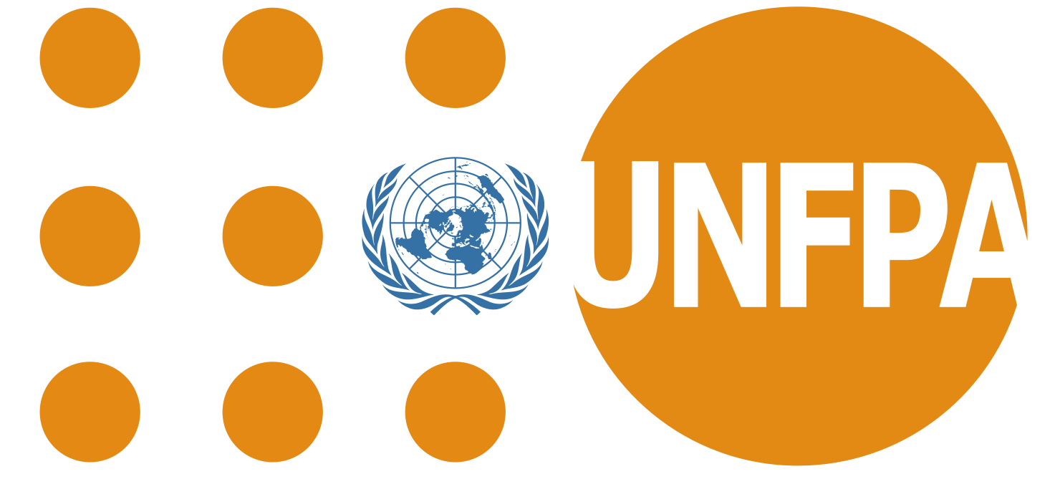

**Pre-Briefing Session: Service Procurement of Media buying Organization for the launch and delivery of campaign on Intimate Partner Violence**

**Attendees:**

* Dr. Harischandra Yakandawala, The Video Team (Pvt) Ltd
* Sanath Mediwaka, The Video Team (Pvt) Ltd
* Rohith Hettiaratchi, Media Factory (Pvt.) Ltd.
* Bratheepa Puvirajasekaram, Media Factory (Pvt.) Ltd.
* Ryan Rebeira, Media Factory (Pvt.) Ltd.
* Sharika Cooray, UNFPA
* Kenosha Kumaresan, UNFPA
* Geetha Fernando, UNFPA
* Anishka Wijayarathne, UNFPA

*Introduction on the campaign and objective of the media buying organization was briefly explained by Sharika Cooray, UNFPA.*

**Q&A Session:**

Rohith Hettiaratchi, Media Factory (Pvt.) Ltd:

**Q:** Clarify the duration of the TVC and radio commercials?   
**A:** 15-30 Secs.

**Q:** Is it possible to give a budget indication for better negotiation and understand the budget allocation?  
**A:** Rough budget estimate would be 90,000 – 95,000 USD

**Q:** Time period?   
**A:** June – Dec 2021. Focusing more on TV, Radio, Digital (banners etc.) less focus on print

Ryan Rebeira, Media Factory (Pvt.) Ltd

**Q:** Has social media content been already created for his campaign?   
**A:** All creative content will be provided.

**Q:** Will social media content be running on the UNFPA page?   
**A:** More focus will be required on digital media such as Hiru gossip pages, daily mirror and suggest a few where UNFPA can get optimum reach among the target audience.

**Q:** Are you considering Google Display Network?   
**A:** The best ideas for optimum reach can be suggested by the Organization, the strategic direction can be defined by the organization keeping the target audience in mind.   
  
**Q:** What type of content will be created?  
**A:** Animated videos, high profile interviews, discussions. Commercials 30 sec. and 15 sec. Jingles etc.   
For digital media: The concept is based on queen of hearts – Sizing and dimensions can be adjusted according to your requests.

**Q:** have you developed any video content particularly for the digital platforms, Like 5 sec. YouTube videos?  
**A:** This has not been considered yet, but UNFPA can work with the creative company to develop such content if suggested.

**Q:** Are there any videos ready?  
**A:** unfortunately there’s no video ready yet. Its’s still in progress

**Q:** Can you share the image for the busts stand? To get an idea of what type of content will be going out   
**A:** The content is very sensitive in nature, it’s a very delicate issue. Since IPV is raising, UNFPA would like to increase more funding for response and prevention. The issue should be the main highlight. When selecting media organizations kindly consider the furthest reach especially in areas out of combo. (In all three languages)

Dr. Harischandra Yakandawala, The Video Team (Pvt) Ltd:

**Q:** Can the WWS findings be shared?  
**A:** The survey is available online at the DCS website. However, the statistics and all the necessary information will be given to the selected organization

Rohith Hettiaratchi, Media Factory (Pvt.) Ltd:

**Q:** What we have to do is buy channels with the best benefits for the investment.  
**A:** UNFPA would mainly consider the cost, benefits, and national level reach among the target audiences.

**Other discussion points:**

* A kind reminder to share all the requested documents in the RFQ when submitting proposals
* All submissions have to be submitted online through email as mentioned in the ToR
* Since there is a restriction of size to be shared submitting organizations are free to share a link to be downloaded or separate emails with multiple numbered attachments

**Action points:**

* Kenosha to share a picture of the queen of hearts which was displayed in the Colombo bus stands